# Sample Question

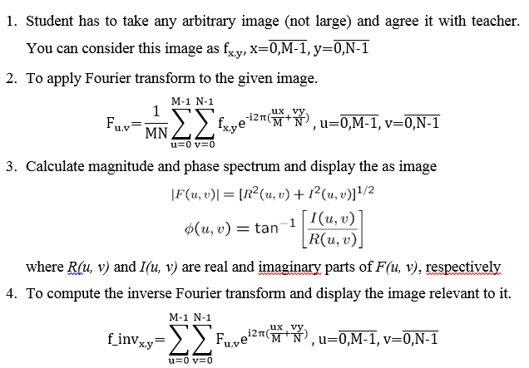

# Sample Code

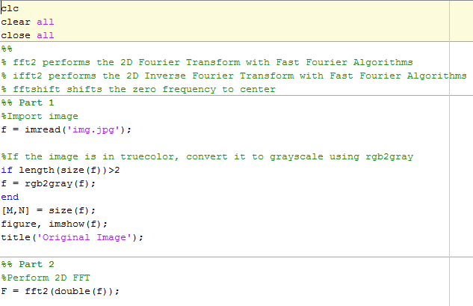

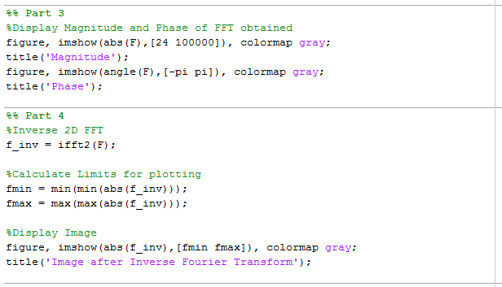

# Sample Explanation

Part 1

imread function is used to load the image in the f variable.

It is stored in uint8 matrix format.

rgb2gray is a function to convert a truecolor image to grayscale.

size function returns the size in M x N form.

imshow is used to display the image.

Part2

Here, fft2 function is used to perform Fourier Transform.

fft2 uses fast fourier algorithm to perform the transform.

Transform is stored in F variable.

Part 3

This part is to display the magnitude and phase spectrum.

abs function is used to obtain the absolute value or magnitude from the transform F.

angle function is used to obtain the phase from transform F.

Note that while displaying the magnitude and phase plots here, we have used [min max] range of scaling. This defines, in case of magnitude every value less than 24 is shown as 24 and value greater than 100000 as 100000 so as to deal with values out of bounds. And in case of phase similarly, we have considered the range only between -pi to pi.

colormap gray defines that we want to plot the spectrum in grayscale.

Part 4

ifft2 function is used to perform inverse fourier transform and store the result in f_inv variable.

To plot the f_inv, we need to find its minimum and maximum bounds to plot.

Then imshow is used to plot the magnitude of f_inv from bounds [fmin fmax].

# Sample Result

